Configure environments for a custom pipeline host
Scenario
You are a Microsoft Power Platform administrator and need to create an environment that acts as the custom pipeline host.
Task 1: Configure environments for a custom pipeline host
Your first task is to create an environment.
- Sign in to the Power Platform admin center with a user who has the Microsoft Power Platform administrator or Global administrator role.
- Select Environments from the left navigation pane.
- Select + New, enter a name, and then ensure that Dataverse is turned on.
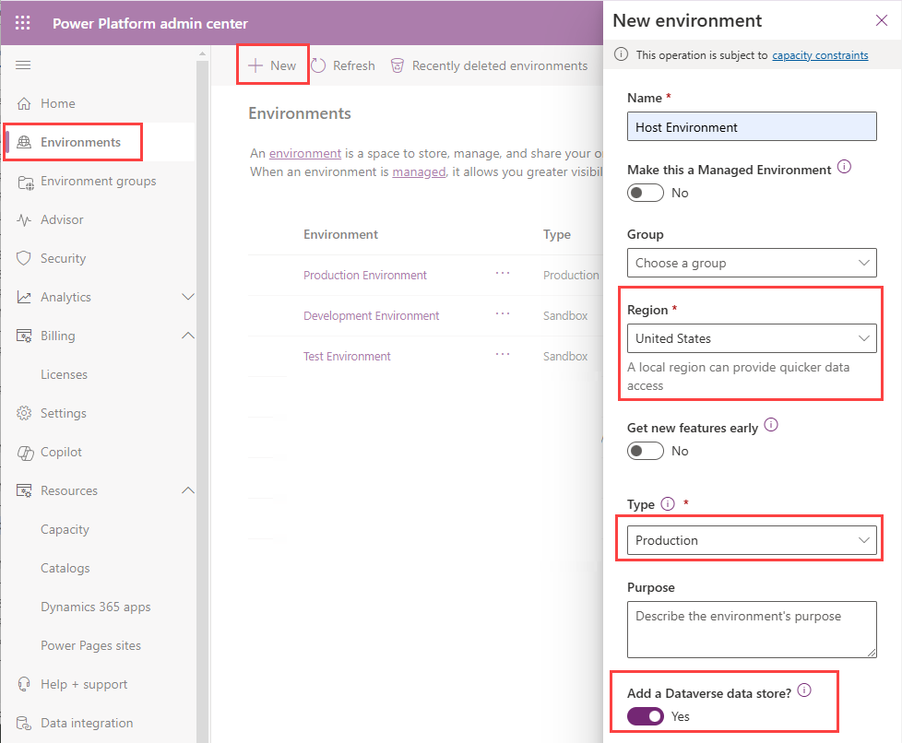
Next, you need to install the Power Platform Pipelines application in the environment.
- In the Power Platform admin center, select the environment that you created.
- Select Resources and then select Dynamics 365 apps.
- Select Install app and then scroll down in the right panel until you find Power Platform Pipelines.
- Select Next, select I agree to the terms of service, and then select Install.
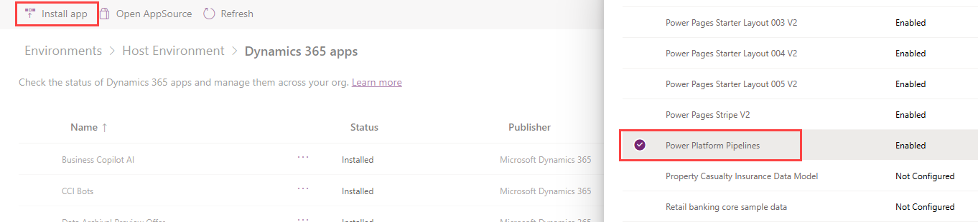
Next, you need to assign security roles.
- In the Power Platform admin center, select Environments from the left navigation pane and then select a host environment.
- In the right panel, select Users.
- Select your user and then select the Manage security roles button in the command bar.
- Verify that the Deployment Pipeline Administrator security role is assigned.
- Select Save.
Task 2: Create and run a pipeline
In Power Apps Studio, select the source environment, and then access the Solutions section in the left navigation pane. The solution browser area has two options for you to access the pipeline management area:
- Select the unmanaged solution to deploy, and then select Deploy in the upper menu.
- Select Pipelines in the left menu.
The pipeline management area has two options for creating a new pipeline:
- Select Create pipeline from the upper menu.
- Select Create new pipeline below the Pipeline dropdown list.
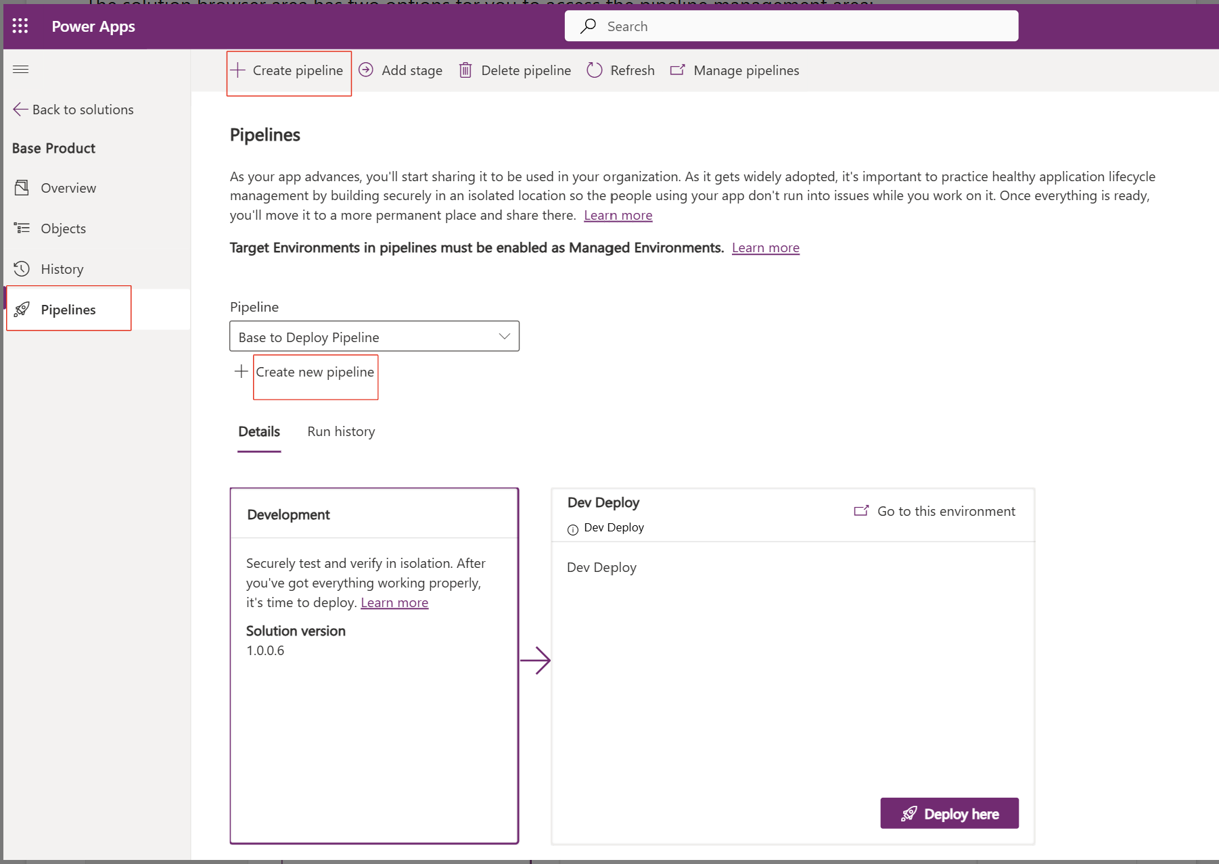
Provide a name, such as Demo Deployment to UAT, and an optional description. Then, select the target environment where you want to deploy the managed solution.
After you save the pipeline, you can use it to deploy a solution by selecting Deploy from the Solutions section, as previously described. After you select that pipeline from the dropdown list, select Deploy here.
To select the location and time of the deployment, follow these steps:
- Select the target environment, such as UAT environment.
- Schedule the deployment for a specific date and time, such as today's date at 8:00 PM.
- Select Next.
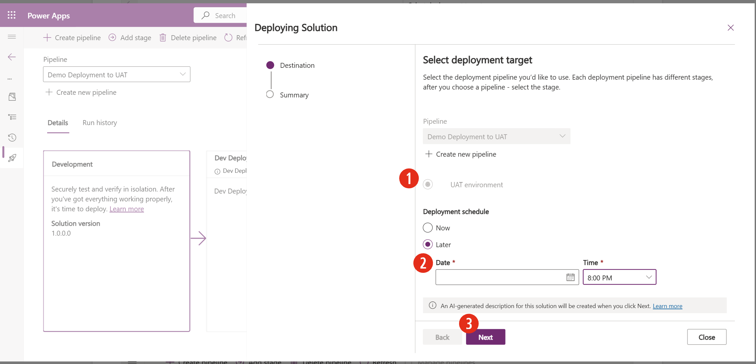
If connections are in the solution, you can make adjustments to the accounts that you want to use with these connections. Finally, when the system presents an AI-generated summary for validation, select Deploy to complete the deployment request process.
After the deployment completes, a status message displays in the target environment tile to confirm successful completion.
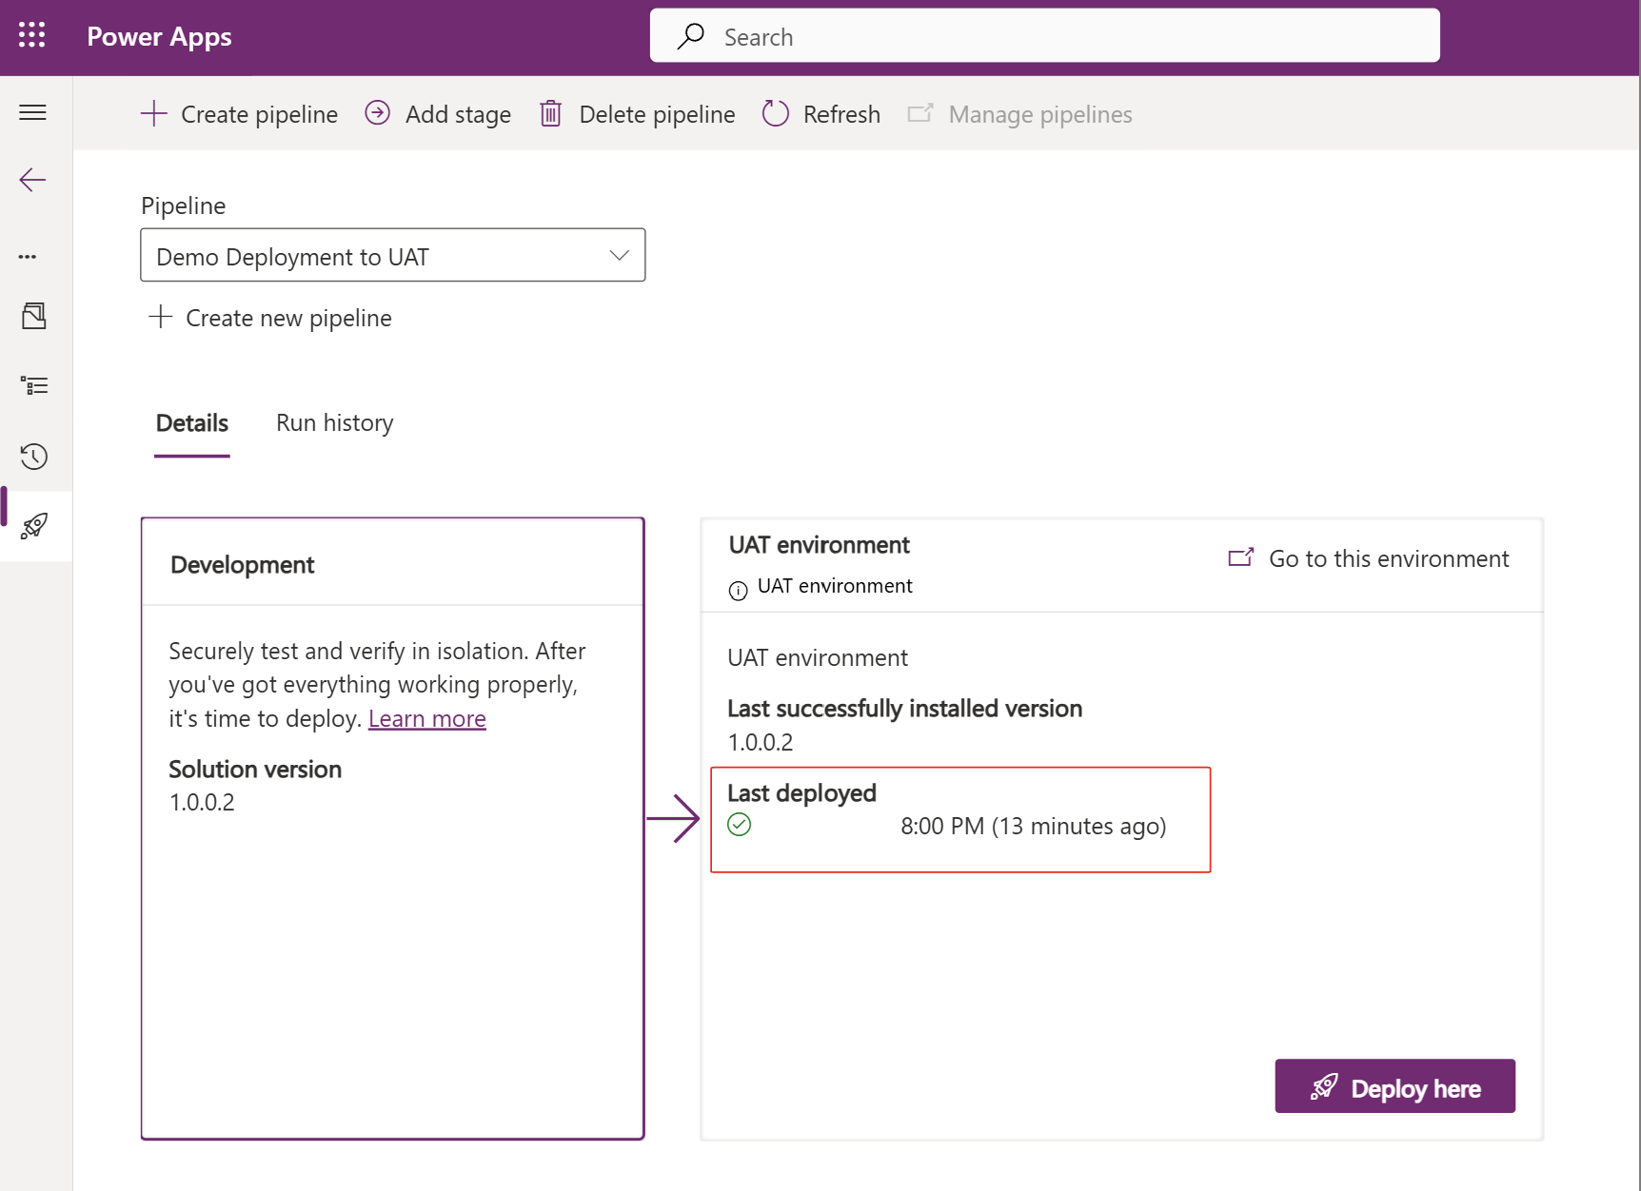
Share the pipeline with a teammate
Scenario
You're working with a colleague on a canvas app from Power Apps in which you have set up a pipeline to deploy from your common development environment to a testing environment. You plan to be away from the office for the next few weeks, and you want to ensure that your colleague can use the pipeline to deploy the solution that contains this app in your absence.
Preparation
Create or identify a user who has access to the source and target environments with permissions to export and import solutions in them.
Exercise
Before beginning this exercise, sign in to Power Apps Studio and select the source environment where you created the pipeline.
Go to the solution that you want to deploy, and then follow these steps:
- Select Pipelines from the left navigation pane.
- Select the Demo Deployment to UAT pipeline or the one that you created previously.
- Select Manage pipelines to access the platform-hosted app.
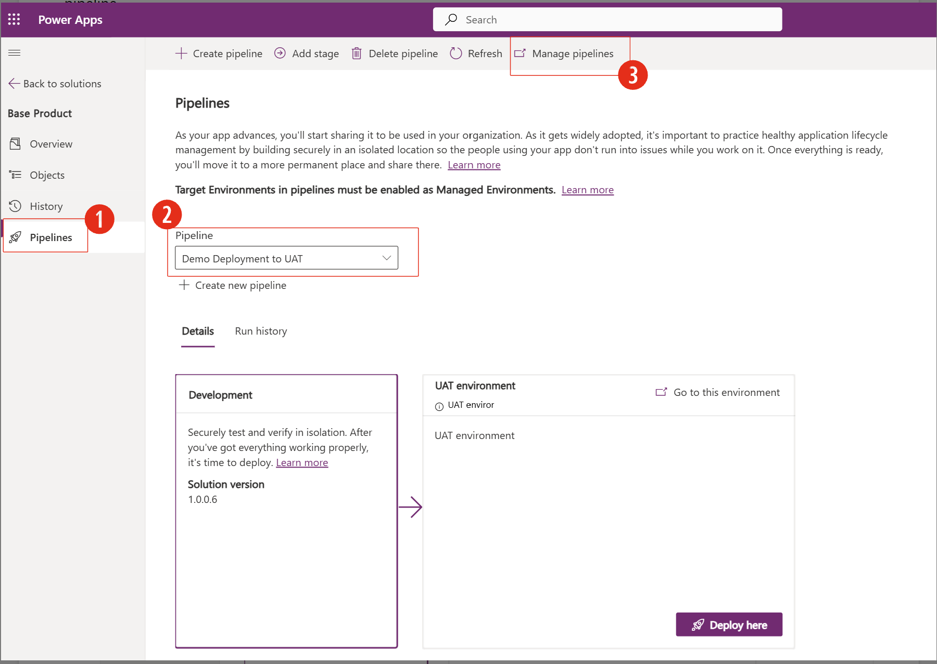
To share the pipeline with your colleague, follow these steps:
- Select Pipelines from the left navigation pane of the app.
- Select the pipeline to share in the list.
- Select Share from the upper navigation bar of the app.
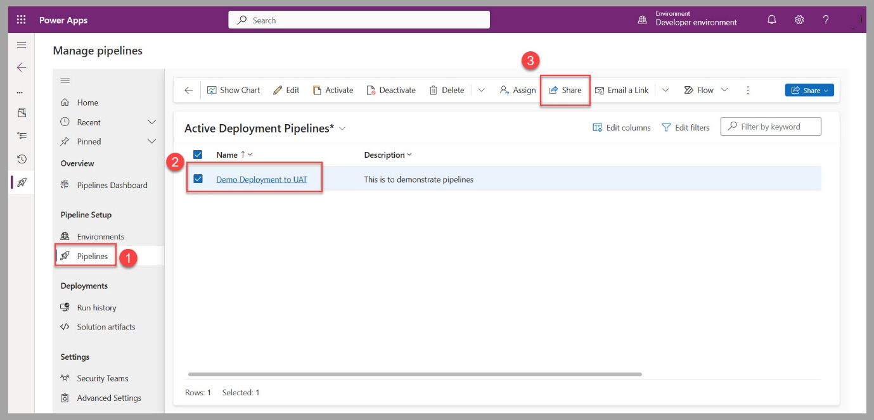
- Search for your colleague's name in the Add user/team field.
- Select your colleague's name from the list of users in the Manage share access section.
- To provide view and deploy capabilities, select Read and Append to permissions.
- Select Share to complete this process.
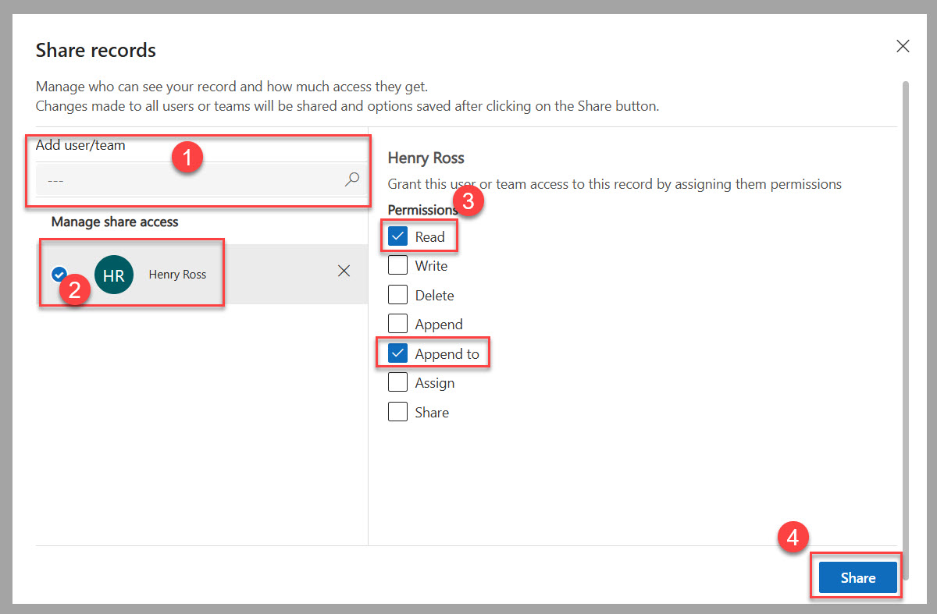
This user now has access to the pipeline and deployment solutions from the source environment to the target environment.

